Master Document — Team Page Mock Sprint
Worked example — Team Byte Size
The git urls are fake – this is just an example

[Login Restyling Bootstrap] Task 1 —Write Requirements: Team Page & Login Styling
Role | BA — Jahan Haidari | Date | Thursday, 6 August 2026
Completion comment
Done: Documented required fields for the team page.
Note: The login work is only for the styling no changes are made to the existing authentication login and session behaviour.
Edge case and expected behaviour?
Edge case | Expected Behaviour
User enters invalid credentials | Show error message this is existing behaviour but restyled with red text for better visibility.
User is logged in | Redirect directly to team page (existing behaviour)
Member has no photo | Display placeholder avatar initials or the default icon
Member blurb exceeds 200 char | Truncate with ... or allow scrolling within the card
Member has no blurb | Display nothing in that space (no empty placeholder)
Team page has many members | Display is a responsive grid like 3 columns wrapping on desktop
User tried to access team page without login | Redirect to login page (existing behaviour)

Group 77, Reviewer Tracking Evaluation For PJS TEAM A

Name | Role | Blurb | Photo
Connor Eyles | PM – Project Manager | As the project manager for group 77, I keep the team aligned with our goals and ensure we deliver on time. I manage the backlog, facilitate meetings, and make sure everyone has what they need to succeed in the team. | 
Martel Kho | DEV 1 - Developer | I’m a developer on group 77, responsible for building the frontend and implementing features. I focus on writing clean, maintainable code and ensuring the app works seamlessly for the users.  I also help in backend tasks! | 
Pasang Lhamu Sherpa | DEV 2 - Developer | I'm a developer on group 77, working on both frontend and backend tasks. I'm passionate about solving technical challenges and making sure our code is robust and well tested. | 
Mahin Mubashir Islam | UX - Designer | As the UX designer for group 77, I create intuitive and visually appealing designs that enhance the user experience. I translate requirements into mockups and ensure our interface is both functional and beautiful. | 
Jahan Haidari | BA – Business Analyst | I'm the business analyst for group 77, responsible for gathering requirements, documenting specifications, and bridging the gap between the client and our development team. I ensure we deliver exactly what the client needs. | 

Deliverable: Mock sprint requirements group 77 Loop workspace document committed to team repo under /doc branch.
Note for next role: UX designer use these requirements to design the login page and team page mockups. Requirements are marked "styling only" for the login page do not change validation or authentication logic.
Git URL: https://github.com/connor9838/task2-garage-boilerplate-basic/blob/docs/G77%20Team%20A%20Mock%20PRD.pdf

[Login Restyling Bootstrap] Task 2 — Design Login Style & Team Page Layout
Role | UX — Sam Okafor | Date | Tuesday, 4 August 2026
Completion comment
Done: Produced mockups for the restyled login page and the team page layout, including the placeholder-avatar and long-blurb cases BA flagged.
Deliverable: Figma file, linked from the team repo.
Note for next role: BA — the long-blurb case is handled with a "read more" expand rather than truncation. Please confirm that's acceptable before you approve.

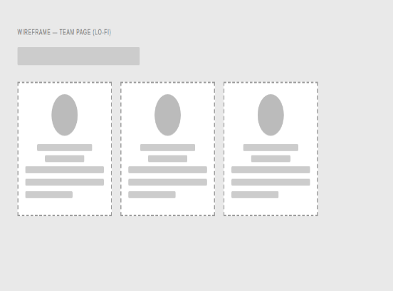

[Login Restyling Bootstrap] Task 3 — Validate Design Against Requirements
Role | BA — Jordan Patel | Date | Tuesday, 4 August 2026
Completion comment
Done: Checked both mockups against the requirements doc. All fields present, login scope stayed to styling only, placeholder-avatar and long-blurb cases both covered. Approved as-is, no changes requested.
Deliverable: Design validation sign-off, committed to the team repo.
Note for next role: Dev — you're clear to build exactly to the Figma file, no open questions from BA's side.
Git URL: https://github.com/team-byte-size/team-page/blob/main/docs/design-validation.md

[Login Restyling Bootstrap] Task 4 — Style Login Page
Role | Dev 1 — Riley Chen | Date | Wednesday, 5 August 2026
Completion comment
Done: Applied the approved login styling (colors, layout, branding). Confirmed auth logic, validation, and session handling are all untouched.
Deliverable: Branch/commit with the styling changes.
Note for next role: Nothing blocking — moving straight on to the team page build myself.
Git URL (commit): https://github.com/team-byte-size/team-page/commit/4a1c9e2

REAL OUTPUT — rendered login page
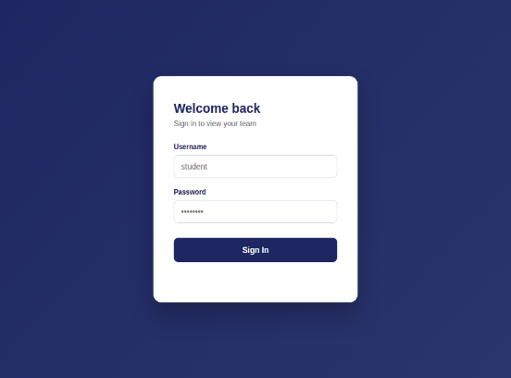

[Login Restyling Bootstrap] Task 5 — Build Team Page & Auth Redirect
Role | Dev 1 — Riley Chen | Date | Wednesday, 5 August 2026
Completion comment
Done: Team page built per the design (name, member cards with photo/role, about-us blurb with expand-on-long-text). Login now redirects here on success; team page redirects back to login if accessed directly without a session.
Deliverable: Branch/commit with the team page and route guard.
Note for next role: Dev 2 — please test against the deployed URL once it's live, not localhost.
Git URL (commit): https://github.com/team-byte-size/team-page/commit/7f3b8d1
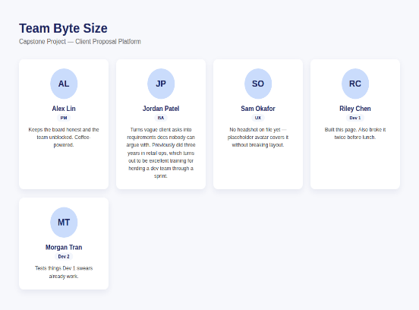

[Login Restyling Bootstrap] Task 6 — Test Login → Redirect → Team Page Flow
Role | Dev 2 — Morgan Tran | Date | Thursday, 6 August 2026
Completion comment
Done: Tested the full happy path on the deployed URL — valid login, redirect fires, all member cards render correctly with photo/role/blurb, expand-on-long-text works.
Deliverable: Test script and test report.
Note for next role: No issues found on the happy path. Moving on to edge cases next.
Git URL (test script): https://github.com/team-byte-size/team-page/blob/main/tests/flow.spec.js
Git URL (test report): https://github.com/team-byte-size/team-page/blob/main/docs/test-report-flow.md

[Login Restyling Bootstrap] Task 7 — Test Edge Cases & Log Bugs
Role | Dev 2 — Morgan Tran | Date | Thursday, 6 August 2026
Completion comment
Done: Tested invalid login, direct team-page URL access without login, missing-photo member, and an unusually long blurb. No bugs found.
Deliverable: Edge case test report.
Note for next role: PM — everything passed, nothing outstanding for Dev 1 to fix before your review.
Git URL (test script): https://github.com/team-byte-size/team-page/blob/main/tests/edge.spec.js
[ IMAGE PLACEHOLDER — Invalid login error state screenshot — replace with actual screenshot ]

[Login Restyling Bootstrap] Task 8 — Final Review & Sign-Off
Role | PM — Alex Lin | Date | Friday, 7 August 2026
Completion comment
Done: Reviewed the feature end-to-end against the requirements and design. Verified every prior task's checklist and completion comment. Everything matches — approved.
Deliverable: Sign-off note.
Note for next role: None — feature complete, board closed out.
Git URL: https://github.com/team-byte-size/team-page/blob/main/docs/signoff.md

